Cells

All living things are made of cells. Your body is made of cells. A bird and a tree are also made of cells. Different living things have different numbers of cells. Small animals have fewer cells than large animals.

- An amoeba is just one cell in size.
- A worm can have thousands of cells.
- A bird has millions of cells.
- Your body has trillions of cells.

Cells in your body are very small. But each cell does not work alone. Cells work together. Just think about doing a chin-up. Nerve cells work together to send messages through your body Bone cells work together to support, or hold up, your body Muscle cells work together to more your body. In this book, you will learn about cells and how they work together in your body.

How Cells Are Alike
There are many different kinds of cells. Each kind of cell does a different job. Yet all cells are alike in some ways. Cells have a nucleus. The nucleus tells the cell what to do. All cells also have other organelles. Each kind of organelle has a different job to do. Organelles do jobs that help cells live.

How Cells Are Different
Cells have a nucleus and other organelles. But there are many kinds of cells. Each kind of cell is different from other kinds.

Your body has many different kinds of cells. For example, you have nerve cells, fat cells, and blood cells. Different kinds of cells have different jobs to do. The size and shape of a cell depends on its job.
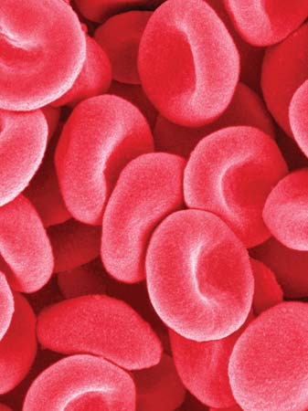

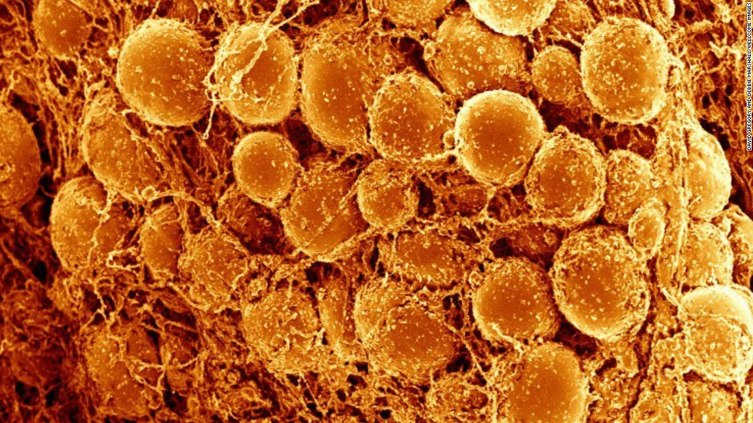
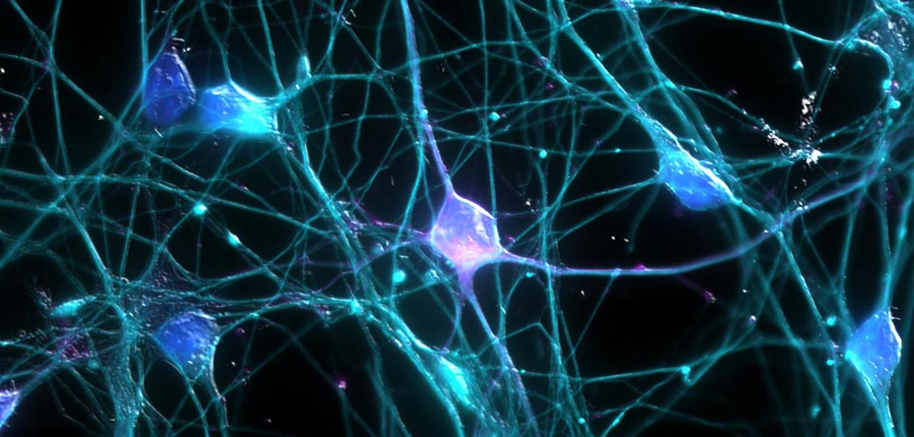

nerve cells fat cells blood cells

Cells Form Tissues
Cells do a lot of work in your body. Yet each cell cannot do much on its own. For example, one bone cell cannot support your body. To support your body, many bone cells must work together.

A group of similar cells that work together to do a job is called a tissue. Bone cells form bone tissue. There are many kinds of tissues in your body.

Tissues Form Organs
Tissues do many jobs. But there are some jobs tissues cannot do on their own. Tissues work together to do bigger jobs. A group of tissues that work together to do a job is an organ.

Your body has many organs. Your brain, lungs, and heart are organs. The tissues in your brain work together to control your body. The tissues in your lungs work together to let you breathe. The tissues in your heart work together to move blood through your body. These are just a few of the organs that do jobs in your body.

Organs Form Systems
Some jobs are too big for just one organ. A group of organs can work together to form a system. A system can do a big job for the body.

The digestive system is a group of organs that work together to break down food. Food gives your body the nutrients it needs to live and grow.

From From Cells to Systems by Rebecca L. Johnson

