Challenger Deep
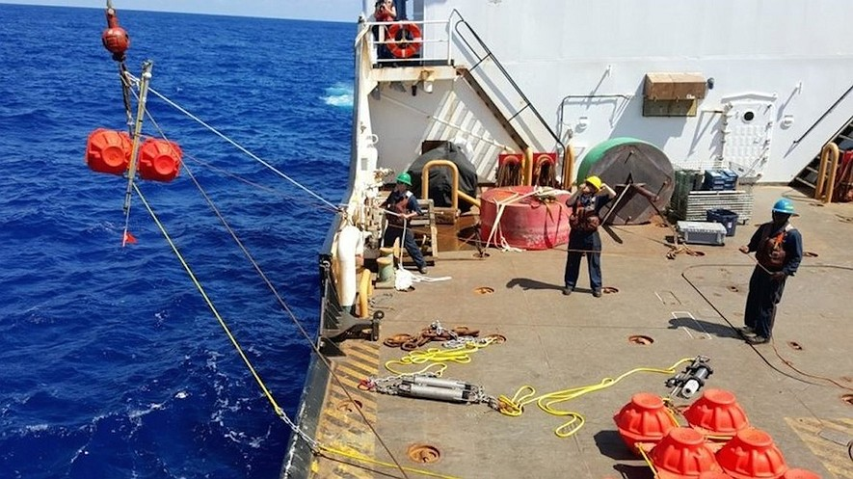

SEATTLE, Wash. — The deepest part of the ocean is called the Challenger Deep. Scientists lowered a special microphone down into it. The microphone picked up sounds underwater. Scientists found out that the Challenger Deep is a very noisy place.

The Challenger Deep is in a cut-out area at the bottom of the Pacific Ocean. The cut is called a trench. It is very long and wide. It is also very deep. If Earth's highest mountain was dropped into it, the mountain would still be underwater.
There are many trenches in the world's oceans. They formed when two parts of Earth moved and ran into each other. One slid under the other.

Scientists Are Surprised
Robert Dziak works for a group that watches the oceans. He says the Challenger Deep should be one of the quietest places in the world. But when scientists listened to the recordings from the microphone, they heard many noises. They heard whales talking and ships passing by. Scientists even caught the sound of an earthquake, the ground shaking.

Not many submarines have been down in the Challenger Deep. Only a few machines have been sent down. Dziak says the recordings might be the first ever captured that deep.

Scientists dropped the microphone down very slowly. It was stopped a little bit above the bottom. They left it there for five months.

Scientists are trying to find out if noise bothers sea life. They want to make maps of the ocean noise.

Earthquakes, Ships And Whales
The microphone picked up many sounds. It recorded earthquakes. They sounded like a train getting closer and closer.

Scientists also heard noise made by ships. It is a higher sound than an earthquake. It also sounds like a tap-tap-tap. The ships made noise all the time.

It was not just earthquakes and ships that scientists heard. The microphone picked up noise from whales and dolphins, too. Whales do not dive very deep. Still, their voices could be heard all the way to the bottom of the ocean.
Scientists even heard a typhoon that was far away. A typhoon is a strong storm. It spins across the top of the water.

The scientists hope to go back to the Challenger Deep. Next time, they will send a camera down, too.

Challenger Deep

SEATTLE, Wash. — The deepest spot in the ocean is called the Challenger Deep. It is also the lowest point on Earth. Recently, scientists lowered a hydrophone, a microphone-like instrument for listening to sound sent underwater, into the Challenger Deep. They discovered that it is a very noisy place.

The Challenger Deep is the lowest part of the Mariana Trench, a crescent-shaped canyon on the bottom of the Pacific Ocean. It is near Micronesia, a group of islands north of the equator and east of the Philippines. The trench is 1,500 miles long and 43 miles wide. It is also more than 7 miles deep. If Mount Everest, Earth's highest mountain, were dropped into the Mariana Trench, its peak would still be covered by more than a mile of water.

There are several trenches like the Mariana. They are a worldwide network of deep troughs that cut across the ocean floor. The trenches formed when two tectonic plates, layers of Earth's crust, collided and one of the plates slid under the other.

Natural And Man-Made Sounds
Robert Dziak is an oceanographer from the state of Oregon. He led the project for a government agency that looks after the world's oceans. He says, “This should be one of the quietest places in the world, but it was a lot noisier than we expected.” Over several months, the hydrophone recorded the booming cries of whales and the rumble of ships passing overhead. It also caught the sound of earthquakes deep in the planet’s crust. “There really is almost constant sound from natural and man-made sources,” Dziak says.
Only a few vessels have ever made it to the bottom of the Challenger Deep. The most recent human visitor was in 2012. Filmmaker James Cameron descended to the bottom in a submarine. A few remotely operated vehicles and instruments have been sent down into the Mariana Trench. Dziak says the recent recordings might be the first ever captured at such great depths.

The 20-inch-long hydrophone was designed by Haru Matsumoto, an engineer from the state of Oregon. He worked with Chris Meinig, a scientist from Seattle, Washington. The recorder is made to stand up to the pressures of the ocean depths in the Challenger Deep. The pressure there could crush a car like paper crumpled in a fist. “We had never put a hydrophone deeper than a mile or so below the surface,” Matsumoto says.

Device Anchored For Five Months
Last July, the United States Coast Guard brought the researchers out to the ocean surface above the trench. The scientists took six hours to drop the hydrophone to the seafloor. They did this to avoid changing pressure too quickly. It was stopped about 20 feet above the bottom, and was anchored in place for five months.

The research is part of a larger effort to keep watch on increasing levels of man-made noise in the world’s oceans. Scientists want to know how noise affects marine life. “Our goal is to make comprehensive sound maps of the ocean," Dziak says. The team chose the Challenger Deep for baseline recordings, a starting point to be used for comparison, because they expected it to be the quietest. They were surprised when they heard the recordings.
The Mariana Trench is a place where two of the planet's tectonic plates crash into each other. The shifting causes earthquakes. The hydrophone recordings of the rumble of the quakes sound like an approaching train.

Whales' Voices Travel Clearly
Scientists also heard noise made by ships. It is higher-pitched and has more of a steady beat. The nearby island of Guam is on a major shipping route, so researchers found that the traffic was a nearly constant source of noise.
In addition to earthquakes and ships, the hydrophone picked up noise from marine mammals. Dziak says that the amount of conversation was unexpected. Few whales dive much deeper than about a mile, yet their voices traveled clearly to the bottom of the trench.

The hydrophone also caught the roar of a typhoon, a powerful, rotating storm that was moving across the ocean surface some 200 miles away. “There was a huge amount of energy, high winds, big waves, that made the whole basin noisy,” Dziak says.

Next, researchers plan to send hydrophones under the Arctic ice cap, a dome-shaped sheet of ice near the North Pole. They want to measure sound levels there before melting opens the area to more ship traffic. Scientists also hope to return to the Challenger Deep next year. This time they also will send a camera down with the microphones.

