Q:
What is a national marine sanctuary?
A:
Of all the amazing places in the United States, some of the most important and special places are in the ocean. Marine Sanctuaries are established to protect areas that hold unique or significant natural and cultural features. Within their protected waters, giant humpback whales raise their young, warm reefs flourish, and shipwrecks tell stories of the people who used the ocean in the past. Sanctuary habitats include beautiful rocky coral reefs, lush kelp forests, whale migration paths, spectacular deep-sea canyons, and underwater archaeological sites. Our nation’s sanctuaries can provide a safe habitat for species close to extinction or protect shipwrecks. These sanctuaries range in size from less than one square mile to 137,792 square miles, about twice the size of New England. Each sanctuary site is a unique place needing special protections. Natural classrooms, cherished recreational spots, and valuable commercial industries—marine sanctuaries represent many things to many people.

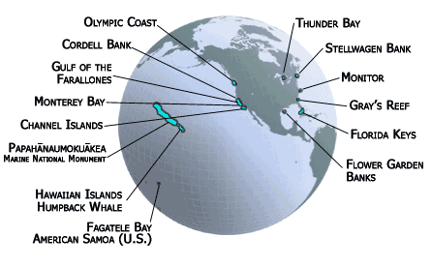

The National Marine Sanctuary System consists of 14 marine protected areas that encompass more than 150,000 square miles of marine and Great Lakes waters around the country.

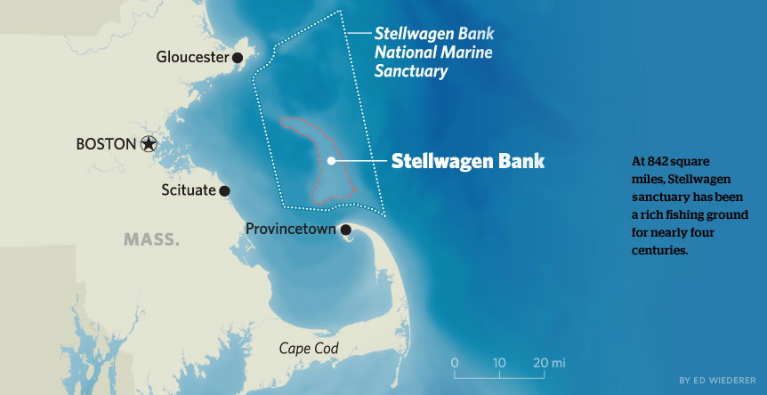

The Stellwagen Bank National Marine Sanctuary is located off the coast of Massachusetts.

Q:
How are the animals and artifacts in marine sanctuaries protected?
A:
Marine Sanctuaries are protected by the Office of National Marine Sanctuaries. This is a group of people within a government group called the National Oceanic and Atmospheric Administration which conducts research on weather, climate, and marine ecosystems and provides education and environmental protection based on what they learn.

The Office of National Marine Sanctuaries manages a national system of fourteen underwater-protected
areas. Since it was established in1972, the Office of National Marine Sanctuaries has worked cooperatively with the people in the communities near these marine sanctuaries to protect these areas of the ocean from potentially harmful human activities while allowing commercial and recreational activities that do not harm the environment. In addition to protecting marine sanctuaries from harm, the Office of National Marine Sanctuaries serves the American people by conducting research and teaching people about the ecology and history hidden in these ocean areas.

Q:
Why is it important to have a sanctuary? Why are sanctuaries important to
coastal communities?
A:
The primary objective of a sanctuary is to protect its natural and cultural features while allowing people to
use and enjoy the ocean in a sustainable way. Sanctuary waters provide a secure habitat for species close to
extinction and protect historically significant shipwrecks
and artifacts. Sanctuaries serve as natural classrooms
and laboratories for schoolchildren and researchers alike
to promote understanding and stewardship of our
oceans. They often are cherished recreational spots for
sport fishing and diving and support commercial
industries such as tourism, fishing, and kelp harvesting.

Q:
How does a marine sanctuary protect ocean animals?
A:
Ocean animals can be protected by protecting their ecosystems. An ecosystem is the community of interrelated organisms (living things) and the environment in which they live. Within a sanctuary, the ecosystem includes all the living organisms, the ocean and its currents, the sea floor and shoreline, and the air and wind above. It may also include the freshwater watersheds that flow into the sanctuary and that are the spawning grounds for salmon and other fish species. Because these various components of ocean ecosystems are interrelated, interfering with one component can affect others.

Sanctuary managers rely on a variety of mechanisms to understand and protect the sanctuary’s living and
historical resources. The National Marine Sanctuaries Act, along with site-specific laws and rules, describe the activities that are allowed or prohibited. Within national marine sanctuaries, a people can sometimes fish, but they need a permit to do so. Sanctuary managers use permits to regulate and oversee potentially harmful activities in sanctuaries. In the Stellwagen Bank National Marine Sanctuary, both commercial and recreational fishing are allowed. However, in order to protect marine ecosystems, people who fish are limited to a certain number of fish of each species each season, and fishing is prohibited in certain areas of the sanctuary at certain times, based on where and when fish spawn. As they give out and check for permits, sanctuary managers also educate people about responsible behavior in order to prevent harmful impacts from occurring in the first place.

Source: National Oceanic & Atmospheric Administration

