Stellwagen Bank National Marine Sanctuary Condition Report

Site History and Resources

Stellwagen Bank National Marine Sanctuary is one of 14 national marine sanctuaries. These are ocean and Great Lakes areas selected for their important ecosystems, opportunities for recreation, historical artifacts, and beauty. This area was set up as a marine sanctuary by the United States congress in 1992. The sanctuary's purpose is to protect the ecosystems and cultural resources in the area while allowing people to use these waters in ways that are not harmful. The group of people in charge of maintaining the sanctuary is part of the National Oceanic and Atmospheric Administration, within the Department of Commerce. A key component of the sanctuary's long-term vision is that the ecosystems in this area will be fully restored.

Land Under Water

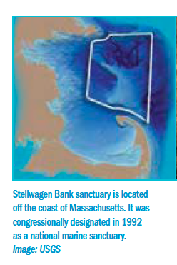
The Stellwagen Bank sanctuary is located in the southwestern Gulf of Maine and stretches between Cape Ann and Cape Cod at the mouth of Massachusetts Bay. The sanctuary is about the size of the state of Rhode Island. The sea floor in this area has a variety of underwater landforms. Geologists, scientists who study the earth's history, estimate that these landforms were created about 14,000 years ago at the time when the glaciers that covered the area during the Ice Age were melting and sliding across the land. During this time, Stellwagen Bank was an island, and mastodons and wooly mammoth roamed about. Today, the dominant feature of the sanctuary is Stellwagen Bank, which is a sandy raised area deposited by glaciers. This narrow, curved underwater island is 19 miles long and 6 miles wide at its widest point. Water depths over and around the bank range from 65 feet (the height of a 5-story building) to more than 600 feet (the height of a tall city building).

Origin of the Name

Stellwagen Bank was named for Henry Stellwagen, the first person to create a map of the bank. Henry Stellwagen was a lieutenant of the U.S. Navy. He mapped Stellwagen Bank in 1854 and 1855 as part of a project mapping the coast for the United States government. The government agency Stellwagen worked for was called the Coast Survey, and its purpose was exploration and mapping of the areas of the ocean around the United States. This organization later grew into the National Oceanic and Atmospheric Organization which, among other responsibilities, manages our national marine sanctuaries.

Setting

Stellwagen Bank and the waters around it serve as one of the most productive fishing areas in the U.S. The area supports marine mammals and fish that are both economic and ecological resources. Because it is relatively easy to get to from the land, the region is used extensively for whale watching and commercial and recreational fishing.

Beginning when New England was a group of colonies, fishing became an important source of income in the area. Since then, there has been a decline in commercial fishing because new methods of fishing caused entire populations of fish to die out. However there continues to be an active fishing business throughout the Gulf of Maine. The productivity of Stellwagen Bank and the surrounding coastline led to 400 years of ship traffic across what is now the sanctuary. As a result, several hundred historic ships have sunken in the area around the sanctuary.

Today, New England has a wide range of sources of income, including creating and selling electrical equipment, packaged foods, weapons, and specialized machinery for businesses. With nearly 4.8 million people living in the area, the unique features and location of Stellwagen Bank bring many resources to more and more people using the area for business and recreation. At the same time, the area needs protection.

Water
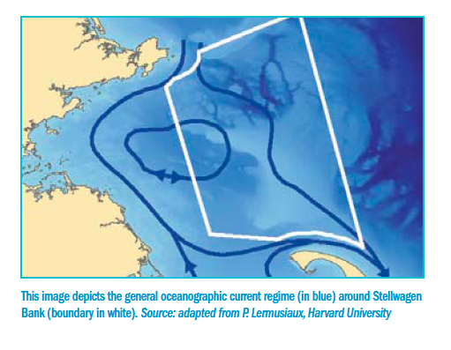
The water around Stellwagen Bank is rich in nutrients, thanks to the ocean currents in this area. The area's complex landforms, along with the flow of rivers into the ocean, winds, and changes between high and low tide, cause a particular pattern of ocean currents. These currents push the water into the edges of the bank. This drives nutrient-rich bottom water to the surface in a process called upwelling. In the sunlit surface waters, the nutrients from below support a rich mix of plankton, which attracts and supports a diversity of marine life. The nutrient-rich waters make Stellwagen Bank sanctuary one of the most important seasonal feeding areas for whales and bluefin tuna in the western North Atlantic.

Habitat

The underwater landscape of the sanctuary, which includes Stellwagen Bank and the area around it, is like a patchwork quilt made of a variety of types of land and covered by a variety of types of organisms. This varied and lively ocean floor can protect animals both from predators and from currents generated by the changing tides or by storms. Some ocean floor areas also enhance capture of prey such as drifting zooplankton and serve as locations for egg laying. This diverse landscape is essential because each species of organism has its own habitat requirements, and individual animals need different habitat components at different stages of their lives.

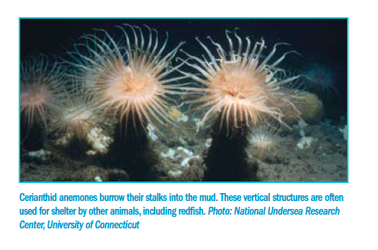
There are five main seafloor habitat types in the Gulf of Maine, and they are all found in the Stellwagen Bank sanctuary. The five habitat types are rocky outcrop (large rock surfaces), piled boulder (piles of rocks), gravel (small rocks), sand, and mud. These habitats are spread across the series of banks and deep basins. Within each habitat type there are many microhabitats formed by the combination of seafloor types and the organisms living there. For example, northern cerianthids, a type of anemone that burrows in mud, serve as important habitat for redfish and hake as the young fish hide from predators among the tentacles of the anemones.
One problem facing the sanctuary is simplification, which is the flattening of three-dimensional structure caused by fishing gear that scrapes against the sea floor. Simplification of seafloor habitat has been shown to increase the mortality of young fish such as Atlantic cod and winter flounder that utilize the structure provided by ocean animals on the sea floor and layers of rock for protection from predators. Studies that use computer models to make predictions have demonstrated that deaths of young fish caused by loss of habitat can significantly decrease the size of a fish population.

Living Resources

Stellwagen Bank sanctuary's nutrient-rich waters and diverse bottom terrain provide habitat for many invertebrate, fish, and seabird species. The abundance of prey species attracts marine mammals, such as the North Atlantic right whale and the humpback whale. Both of these whale species are endangered, and the sanctuary is one of the primary feeding grounds of the humpback whale in the North Atlantic.

A wide variety of invertebrates are present in the sanctuary. This includes large cerianthid anemones, which live in deep mud basins, and sand dollars and sea stars, which live in the shallower sand areas. Structure-forming seafloor animals such as sponges and anemones, provide protection and nursery habitat for juvenile fish of many species, including Atlantic cod and Acadian redfish.
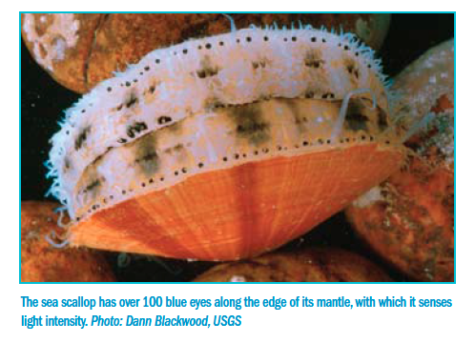
The diverse seafloor habitats support 72 species of fish in the sanctuary. The seafloor fish community includes cod and haddock which are desirable in the fishing industry. It also includes sand lance (a small eel-like fish), mackerel, and herring, which serve as the primary prey of humpback, fin, and minke whales feeding in the sanctuary.

The sanctuary is the seasonal home to two species of endangered sea turtles, the Atlantic ridley and leatherback. The leatherback is the only species of sea turtle that journeys to these cold waters for summer feeding activities. Likely prey include jellyfish that are abundant in these waters during the summer. Atlantic ridleys are observed in waters off Massachusetts as juveniles, having either swum or drifted north in the Gulf Stream from hatching areas off the southern coast of Mexico. In addition to turtles, approximately 43 species of seabirds inhabit the sanctuary at times throughout the year.

Whales are the most visible occupants of sanctuary waters. Seventeen species of marine mammals are known to frequent the sanctuary, humpback whales being perhaps the most noticeable because of their large size, intriguing behavior, and distinctive markings. North Atlantic right whales are some of the world's most endangered whales. Every year, approximately one-third of the North Atlantic right whale population utilizes the sanctuary and nearby waters for feeding and nursing. Fin whales, the second largest of the world's whales, are the most common species of large baleen (toothless) whale in the Gulf of Maine and are regularly seen in the sanctuary, along with the smaller minke whales. Harbor and gray seals are also commonly observed in the sanctuary.
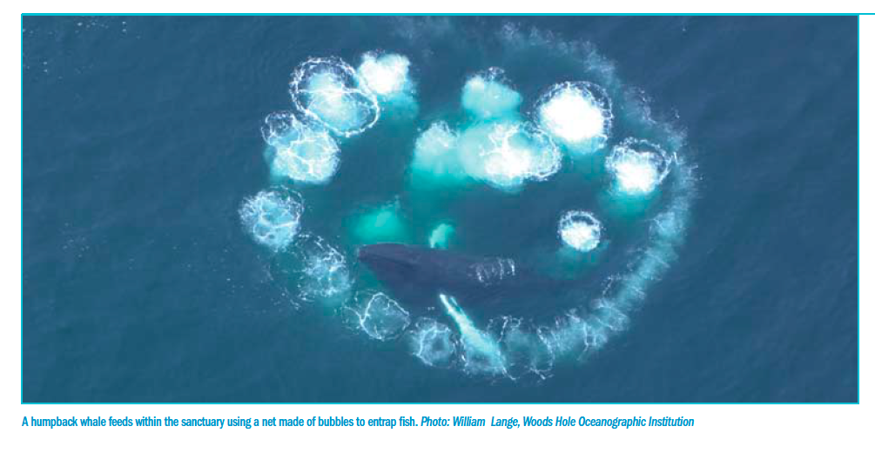

Maritime Archaeological Resources

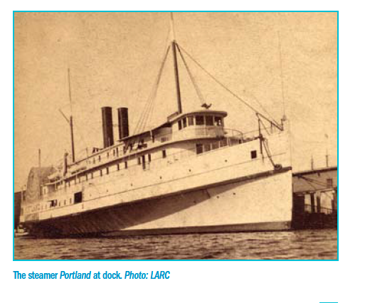
In addition to its ecological resources, the sanctuary contains Archaeological resources that can teach us about our nation's history. Hundreds of years of fishing, whaling, and ocean transportation have made the sanctuary a place with plenty of shipwrecks to study. Since researchers began investigating the sanctuary's historical resources in 2,000, archaeologists have located 18 historic shipwreck sites and identified five of them by name.

The most historically significant shipwreck is a passenger ship called the Portland, which was lost in a storm in 1898. Known as the "Titanic of New England," this large, luxurious steamship was carrying over 100 people when it sank to the ocean floor. The remains were discovered in 1989 and visited by a team of divers in 2008. The divers found plates, pitchers, sinks, and other items scattered around the remains of the ship.

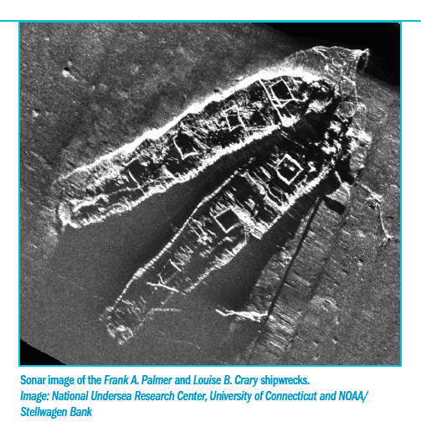
Another archaeological site contains the shipwrecks of two coal-carrying ships that collided in December 1902. The Frank A. Palmer and the Louise B. Crary were bringing coal to Boston when they collided and sank. Sonar images collected in 2002 and 2003 clearly show the hulls of the two large ships, their bows locked together for all time.

Impacts on the Sanctuary

Shipping

Stellwagen Bank sits at the mouth of Massachusetts Bay and is open to ship traffic traveling to and from the Port of Boston, which is a major port for container ships. Ships passing through the sanctuary include cruise liners, container ships (some with hazardous materials), and natural gas and oil tankers. Several problems can be caused by ship traffic through the sanctuary. Noise from ships can interfere with whales' ability to find food, and ships can also strike these animals. Ships also pollute the sanctuary by releasing materials such as water from sinks and showers into the ocean. In addition, organisms are sometimes unintentionally carried across the ocean which can interfere with local ecosystems. Ships contain a component called a ballast tank which is filled with ocean water in order to stabilize the ship. Because the ballast is filled at the ship's departure city and emptied where it arrives, it carries with it a sampling of marine organisms. Sometimes an organism from across the ocean is so successful in a local environment that it interferes with the abilities of native organisms to survive. These organisms are known as invasive species.

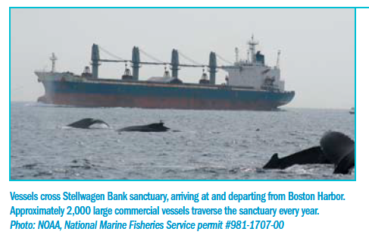

Discharges and Dumping Sites

The Massachusetts Water Resources Authority (MWRA) wastewater treatment plant on Deer Island discharges about 350 million gallons per day of cleaned and treated wastewater 12 miles west of the sanctuary. Water flowing into the sanctuary has the potential to change important properties of the water in the sanctuary. If too many nutrients flow into the water in the sanctuary, algae can grow at an unusually high rate, using up an increased amount of the oxygen in the water. Dissolved oxygen in the water is important for fish and other marine animals.

In addition to water, material from the bottom of the ocean is deposited near the sanctuary. The process of removing material from the bottom of the ocean to deepen channels for boats is known as dredging. Dredge material that is free of hazardous materials may be dumped at the Massachusetts Bay Disposal Site for clean dredge material. This site is located in Stellwagen Basin adjacent to the sanctuary's western boundary. Known hazardous and radioactive materials were dumped in and around this site in the 1940s and 1950s. Given the proximity of the dumpsite to the sanctuary, there is concern that these dumped materials have impacted sanctuary habitats and that barrels with toxic materials could be leaking.

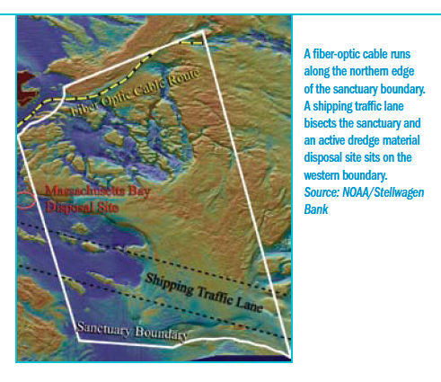
Fiber-Optic Cable

A fiber-optic cable was laid across the northern part of the sanctuary with permission from the federal government in 2000. This cable provides a direct link between North America and the Republic of Ireland. The cable is designed to last for 25 years and is buried at an average depth of approximately 1.5 meters into the seafloor. The major impact is habitat disturbance from the cable laying and burial process and from future repair or removal.

Liquefied Natural Gas Deepwater Port

In 2010, a deepwater port for the off-loading of liquid natural gas was installed approximately two miles west of the western boundary of Stellwagen Bank. A deepwater port is a built structure in the water that allows large ships to deliver materials. Concerns in this area include contamination from discharges, increased ship traffic and noise, displaced commercial fishing and whale watching activities, and impacts to the sanctuary's scenic views.

Noise

The level of noise pollution in the oceans and in the Stellwagen Bank sanctuary has increased dramatically during the last 50 years. The primary source of ocean noise is commercial shipping. Many marine mammals respond to noise by altering their breathing rates, spending more time underwater before coming up for air, changing the depths or speeds of their dives, shielding their young, changing their song note durations, and swimming away from the affected area. Noise pollution also may cause hearing loss in marine mammals and other organisms. Disorientation and hearing loss due to ship noise may be the cause of cases in which ships collide with marine mammals that are apparently unaware of the approaching vessel. Most strikes occur in coastal waters on the continental shelf where large marine mammals concentrate to feed.

Commercial Fishing

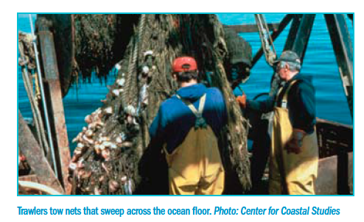
Approximately 440 commercial fishing ships are at work in the sanctuary every year. Commercial fishermen take a variety of ocean animals including groundfish such as cod and haddock, open ocean fish such as herrings and sardines, and invertebrates such as lobster and shrimp. To gather these varied animals, they use a variety of fishing gear including lobster traps, large nets called trawls, and scallop and clam dredges which are heavy steel frames with nets attached that are dragged along the seafloor. Problems that can be caused by commercial fishing include alteration of habitat, removal of organisms, discharge of pollutants, and entanglement of marine mammals.

Commercial Whale Watching

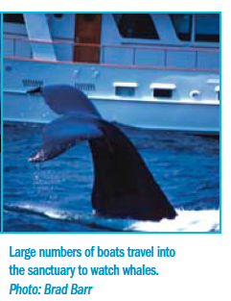
There are 24 commercial whale watching boats that make daily trips into the sanctuary from April through October, and whale watching also takes place in the sanctuary in privately owned boats. More than one million people visit the sanctuary yearly for whale watching. There is increasing concern about the short-term and long-term impacts of whale watching on the whale populations of Stellwagen Bank. Scientists around the world have studied the impacts of human activities on whales. These studies have shown changes in breathing rate and changes in the whales' behavior. For example, some whales have been found to spend less time feeding when boats are near them because they spend more of their time diving to avoid the boats. These concerns are increasingly important, as the popularity of whale watching is increasing.
Recreational Fishing and Boating

The sanctuary is a popular destination for recreational fishing boats, sailboats, and powerboats. It is estimated that people fishing for recreation take 25 percent of the cod in the Gulf of Maine. There are 65 small boat harbors and over 80 boating and yacht clubs along the Massachusetts coast with easy access to the sanctuary. Recreational boaters typically cross the sanctuary going to and from Boston, coming from the Cape Cod Canal or Cape Cod Bay and from Provincetown or Cape Ann. Recreational boaters are most numerous in the sanctuary during the whale watching season from April to October. On a calm summer day, there can be hundreds of recreational boats within the Stellwagen Bank sanctuary. Potential problems from recreational boating and fishing include removal of breeding fish, disturbance of whale feeding, strikes to whales, and discharge of pollutants.

Climate Change

Based on patterns in the data scientists have gathered, climate change is expected to profoundly impact coastal and marine ecosystems over the next century. Climate change can have significant effects on sea level, temperature, and currents. These changes could cause more intense storms and more extreme floods and droughts. Rising seawater temperatures may lead to increased algal blooms, destruction of local species, and an increase in disease-causing organisms.

