What Happens When Your Arm “Falls Asleep”?
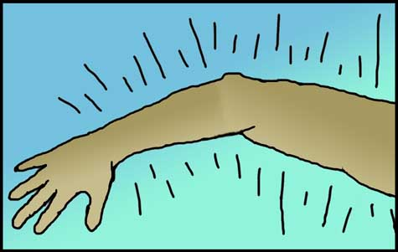
Suddenly you’re awake, but the arm underneath your pillow is not. The crooked limb feels heavy and deadened, and you untuck it with difficulty as that aching, tingling sensation known as “pins and needles” sets in.
What’s happening in your arm technically goes by the name of paresthesia. In most instances, paresthesia occurs when pressure from sleeping or sitting blocks the blood flow to nerve fibers in some part of your anatomy. Nerves need fresh oxygen and nutrients to function properly, and without them, nerves go a bit haywire.
“In paresthesia, it’s like part of the nerve has shorted out,” says Dr. Naomi Kleitman, the program director in repair and plasticity at the National Institute of Neurological Disorders and Stroke in Bethesda, Md. “Some of the sensory signals from your arm can’t get back to your brain the way they normally would.”
Nerve fibers act like electrical wires splayed throughout the body. When they’re working properly, nerves provide a pathway to pass along the brain’s commands and also route sensory information “back upstairs” for processing.
While snoozing , the weight of your head puts pressure on the blood vessels that thread through your arm, cutting off circulation. Such tie-ups prevent energizing sugar and oxygen from reaching the nerve fibers. This blood drought sabotages the normal flow of sensory data to the brain as the parched nerves start firing off messages at random.
“Some of the nerves start discharging spontaneously,” says Dr. Robert LaMotte, a professor of anesthesiology and neurobiology at Yale University in New Haven, Conn. “This sends a chaotic barrage of impulses to the brain.”
Compounding this cacophony is the fact that several kinds of nerves detect different sorts of stimuli. “Some are for temperature, some for touch, and others help you know your place in space,” says Kleitman. When these various feelers get scrambled, the brain misinterprets the signals and generates a range of sensations, including prickly pain, warmth and numbness. This neural static only gets worse after you’ve repositioned the arm and blood gushes back in, further jazzing up those misfiring fibers.
Despite the nerves buzzing under your skin for the next couple of minutes, you are far more annoyed than alarmed as you start to doze off again. But is this paresthesia, even when fleeting, dangerous in any way?
“It is possible to damage your nerves, but probably not through occasionally sleeping funny,” says Kleitman. In experiments to study paresthesia, patients have kept blood pressure cuffs on their arms for over an hour without any permanent ill effect, says Yale’s LaMotte.
Nevertheless, if that tingling sensation isn’t wearing off, it could mean you have a genuine medical problem, like a pinched nerve, for instance. Pinched nerves can strike when bone, muscle or connective tissue inside your body compresses a nerve fiber, rather than an external source, such as the seat of a chair or your resting noggin. A common case of a pinched nerve is carpal tunnel syndrome. This flares up when swollen tendons in the wrist squeeze a nerve that enables feeling and muscle movement in the hand, resulting in uncomfortable paresthetic episodes.
So when it comes to paresthesia, pay attention, and see a doctor if the bothersome sensations don’t fade away.

