Ducks in the Flow

“Hey, Calvin and Anna!” Natalie exclaimed as she hugged her two friends. “It’s great to see you! I wish you could have come with me on vacation!”
Calvin replied, “That would have been great, Natalie. We really missed you. We went to the lake a few times, but I bet it was cool to visit a new place.”
“Well, we went to the beach in Massachusetts right on the Atlantic Ocean, which is a little different than Lake Michigan. Look at the cool stuff I found while I was there!”
Natalie dumped out a beach bag full of things she brought back from her trip, including some things she found at the beach.
“Wow! This stuff is awesome. The shells look cool and swirly,” Anna said. “Hey, that toy duck looks kind
of weird. It is white instead of yellow, and there is some hard material stuck to it. What do you guys think happened to that duck?”
"I was wondering the same thing,” Natalie replied. “I’ve never seen a white plastic duck before, and it looks really dirty. It doesn’t look like the ducks my little brother plays with in the bathtub. I found it sitting in the sand when I was collecting sea shells. I wonder how it got to the beach in Massachusetts.”
“Maybe someone was playing with it in the sand and accidentally left it there. I have lost toys at the lake before when I forgot to pack them up,” said Anna. “It might have been buried in the sand for a long time before you found it.”
“Or maybe it washed up onto shore from the water. We have found lots of things on the beach at the lake, like shoes, toys, and plastic bottles. But I don’t remember ever finding anything with the hard stuff attached. What do you think it is?” asked Calvin.
Natalie exclaimed, “I have an idea! You know that research lab that’s by the beach at the lake where we go swimming? I think the scientists there study the lakes and the beach, so they might know what happened to this duck. Let’s call them to see if we can talk to someone.”
Anna added, “Good idea. And my mom asked if we wanted to go to the lake for a picnic and to go swimming. Maybe we can show it to one of the scientists then.”
Natalie called the research lab and told them that she found a peculiar looking duck. The person she talked to told her to bring her duck to the lab that afternoon and they would take a look at it.
After hanging up the phone, Natalie said to Anna and Calvin, “Ok, we are all set. They want to help us. Someone will be there to talk to us when we go to the lake today!”
There was a man with a small cage waiting outside of the building when they arrived at the research lab. Natalie, Anna, and Calvin walked up to him and he introduced himself. “Hi kids! My name is Mike Yang and I am a research assistant here. I heard you have a duck with a problem. Can I see it?”
Natalie took the rubber duck out of her beach bag and handed it to Mike.
"Oh my gosh!” exclaimed Mike as he started to laugh. “It seems there’s been a misunderstanding. When you said you had a duck that needed help, we thought you meant a live duck that had been injured or was sick! That’s why I brought my cage. So, what seems to be the problem with this plastic duck?”
Calvin said, “Natalie found this when she was on vacation. We were wondering, why it isn’t yellow like most plastic ducks? And what is this hard stuff all over it?”
“Hmmm, those are good questions,” said Mike. “We have a scientist here who will be excited to see your duck, and I am sure she can help you answer your questions. Her name is Dr. Miller, and she is an oceanographer.”
Mike took them to Dr. Miller’s office. He introduced the kids to Dr. Miller and told her they had
a few questions.
Natalie held up her plastic duck and said, “Dr. Miller, what is going on with this duck?”
Dr. Miller exclaimed, “Wow! Where did you find it?”
“I found this on the beach in Massachusetts last week,” Natalie replied. “We were wondering why this duck doesn’t
look the same as normal toy ducks.”
Dr. Miller was very excited when she saw the white plastic duck. “Kids, if I am correct, you have stumbled onto a major research project that is underway!”
“What do you mean, Dr. Miller?” Calvin asked.
“Your duck may be one of the famous plastic ducks that fell into the ocean during a storm in the Pacific Ocean in 1992,” said Dr. Miller. “A container filled with bath toys fell off a cargo ship, and 29,000 toys, including toy ducks, fell into the ocean.”
“Whoa!” Natalie said. “1992? That happened before we were born! I can’t believe this duck was out there in the ocean all that time!”
“Yes,” said Dr. Miller. “Your duck has been lost for a long time. In fact, oceanographers have been using the toys from this accidental spill to learn more about surface currents. We also use scientific tools like this funny-shaped thing leaning on the wall we call a drifter to study surface currents in the ocean and lakes. But the additional information we get from other things floating in the ocean, like your duck, is very helpful.”
"I don’t get it,” said Calvin. “How can a bath toy tell you anything about surface currents?”
“Are surface currents the same as waves?” Natalie asked. “If so, maybe that’s why this duck washed up on the beach!”
“Those are good questions,” said Dr. Miller. “Surface currents aren’t the same as waves. Waves are ripples in the water that are usually caused by wind, and they crash onto the shore of beaches where the water becomes shallow. The direction and height of waves can change every day or even every hour due to the development of storms. Unlike waves, a surface current is water that flows at and below the ocean surface. Because there is so much water in the ocean, surface currents are not affected by storms or brief changes in the direction of the wind. Let’s look at this map. The arrows show the major water currents in the ocean.”
Dr. Miller marked a spot on the map in the Pacific Ocean. “This is where the ducks and other toys fell into the ocean,” she said. “Natalie, why don’t you show us the place where you found your duck?”
Natalie marked the spot on the map where she found the duck on the beach in Massachusetts.
Anna asked, “If the ducks fell into the ocean over here, I can’t figure out how they got all the way over to where Natalie found this duck. How did that happen?”
Dr. Miller replied, “If you really want to know, let me give you some more information about surface currents. There’s lots to learn...”
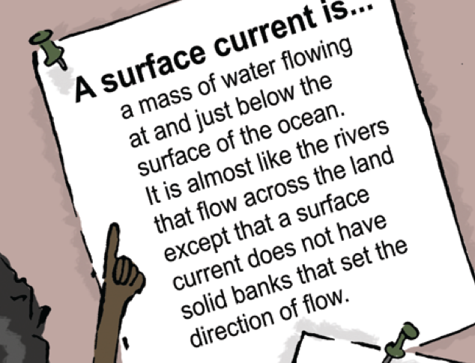

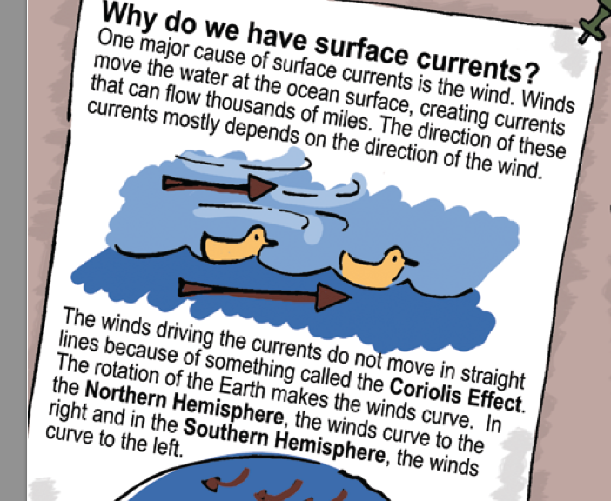
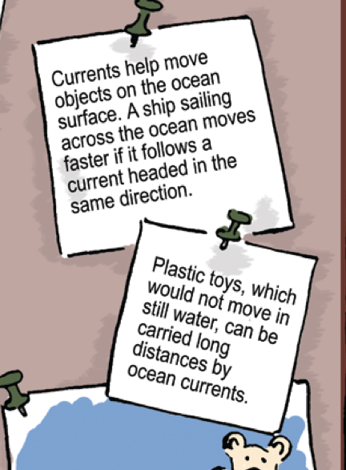

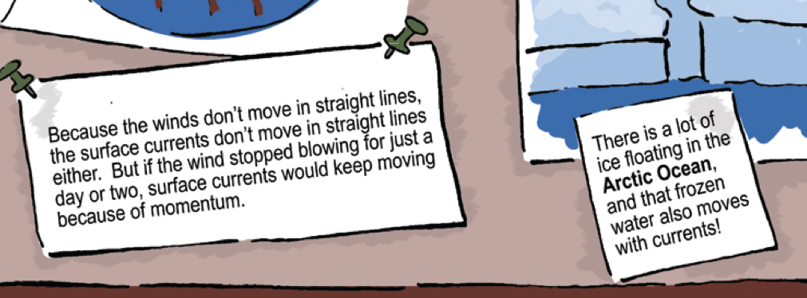

"So you see, kids, surface currents are a very important
part of our world’s ocean,” said Dr. Miller. “Natalie,
the plastic duck you found traveled for years and years, in water and ice, before it
washed ashore on that beach in Massachusetts. During that
time it turned from yellow to white due to the sun, water,
and ice. I believe that these hard things on the duck are barnacles. Barnacles are little sea creatures that survive by attaching themselves to objects in the water like boats, rocks, or docks. These little animals settle down and build their homes from minerals in the water. It looks like these barnacles found a home on your duck.”
Natalie was really excited. “That’s so cool! I am so lucky that I found this duck!” she exclaimed.
“Natalie, there’s another cool thing about your duck” Dr. Miller added. “I heard that the company that made these ducks is offering a cash reward if you send it back to them. This will allow them to help the scientists who are studying ocean currents.”
Calvin, Anna, and Natalie looked at each other and smiled. They were excited to hear about the reward.
“How do we get the reward?” Calvin asked.
"I'm not sure,” Dr. Miller responded. “You will have to look that up. Please let me know what you find out! Next week we are having a Lakeside Festival. You all should come back for it. There will be lots of games and ways to learn more about the lake and the research we do here. It will be a lot of fun.”
“Thanks, Dr. Miller! We’ll try to come back next week!” Anna said,.
As the kids left the lab and walked back to the beach, they giggled and exchanged sly grins. “I wonder if there really is a reward for these ducks!” Calvin said. “If we find more ducks, we could make a lot of money!”
“Yeah! I wonder if they have washed up on our beach here at Lake Michigan!” Natalie exclaimed. “Hey, we should check that out. Let’s look for more ducks on the beach before we have to go home.”
Natalie, Anna, and Calvin headed down to the
beach. They decided to split up so they could cover more area and look for
ducks in different spots. After a while they met back up. None of them had found a plastic duck. The kids
could not help feeling a little disappointed.
“I looked really carefully, but I didn’t see any toy ducks!” said Calvin. “But I did find this old buoy that looks like it washed up on shore. What
did you find, Anna?”
Anna showed them the plants she found washed up on the beach.
“Natalie,” Anna asked, “Do these things look like the stuff you found on the beach in Massachusetts?”
“Let’s see, I think all of it is still in this beach bag,” Natalie replied. They made two piles on their beach blanket.
Anna pointed out, “The shells we found today don’t look the same as the ones you found on the ocean beach.”
“You’re right, Anna,” Calvin said.
Natalie added, “I found plants washed up on the shore today at the lake, and I saw plant-like stuff called algae at the ocean beach. Also, the water at the ocean is salty and it isn’t salty here at the lake.”
“Natalie, what is the same at the two beaches?” Calvin asked.
“Well, like we said, both beaches have sand,” Natalie said. “Also, both beaches have waves, and you can’t see any land when you look across the water.”
Calvin added, “Dr. Miller told us that this lake has surface currents, and the ocean also has surface currents. That’s the same. The surface currents probably carried the buoy that I found to this beach. So maybe surface currents could also bring the ducks to our beach, and we just didn’t find any today!”
“Good idea! When we go home we should look at some maps to see if the surface currents will bring the ducks to our beach! And let’s do what Dr. Miller suggested and find out more about the reward.” Anna said.
The next day they met again at Natalie’s house. They decided to learn more about the ducks’ journeys and the path that Natalie’s duck took to get to the beach where she found it. They also wanted to learn more about the reward that Dr. Miller mentioned.
Calvin announced, “Last night my mom and I used the Internet to find the company that made the duck. They will give you $100 for each duck you return! I hope we can figure out where to find more of them!”
Anna read a bunch of articles on the Internet about people who had found the ducks in different places in the world. “Wow,” she said, “Since 1992, when the ducks fell into the ocean, they have washed up on shore in Alaska, Washington state, and British Columbia, Canada. Some also went south towards Australia. Let’s mark all of those places on our map.”
Calvin had spent time the previous night learning more about ocean surface currents from his sister’s oceanography book, and he drew the surface currents onto their map.
"Okay, so we know how the ducks got from the Pacific Ocean into the Atlantic Ocean. But how will they get from the Atlantic Ocean into our lake?” Calvin asked.
Natalie pulled out another map that showed the details of the Great Lakes. “Here’s where we are in Lake Michigan,” she said, pointing to the map. To get from the Atlantic Ocean to here, basically all you have to do is flow along the St. Lawrence River and through Lake Ontario, Lake Erie, and Lake Huron to get to Lake Michigan. Hmmm, that actually seems really far, but
I guess if the ducks could make it from the Pacific Ocean to the Atlantic Ocean, it isn’t such a big deal.”
“Wait! I think we have a problem here!” Anna called out. “This book explains that the St. Lawrence River flows from Lake Ontario out into the ocean, not the other way around! Maybe the reason there aren’t any ducks on our beach is because they can’t get in here!”
“Oh no!” Calvin said. “This means we won’t be able to collect any more ducks for a reward.”

After Natalie marked the spot where she found her duck in Massachusetts, she asked, “How do you think the ducks got from that side of the world to the side where I found this one? Isn’t this all ice?”
Anna responded, “Yeah, it is ice up there! I just read that they think the ducks ended up in the sea ice. That ice can move with the surface currents. The ice eventually melts in the Atlantic Ocean over here, and that’s how our duck got into this ocean. Then it must have been in these surface currents before it washed up on the beach.”
"I have an idea!” Anna exclaimed. “My mom said she wanted to take a beach vacation this spring break. She asked our family to vote on which beach we should visit. Let’s figure out where the ducks are going to show up next and maybe our family can go there for our vacation and we can find more ducks!”
They pulled out their map and looked at all of the places where the ducks had landed.
“Well, the duck I found must have gotten to that beach from the Labrador Current,” Natalie said. “So, looking at our map, it looks like ducks could also go this way on the Gulf Stream and the North Atlantic Current all the way to England!”
"Don’t some of the ducks just stay out in the ocean, traveling in the currents?” Calvin asked.
“Yes, that’s what I read. Only some of them wash up on shore,” Anna replied. “Some of the toy ducks may never wash up on a beach. But from the looks of the map, I think the next place someone might find a
duck is in England or Scotland. Hmm, I wonder if my family wants to go there for our beach vacation. I’ll have to ask them!”
The next day Anna reported to her friends, “Bad news. My family thought the beaches in England
would not be warm enough over spring break, but my mom also reminded me that we are going to drive to the beach we
visit, so England is definitely out of the question.” “Oh well, it was worth a try!” Natalie said.
Calvin asked, “Hey, isn’t the Lakeside Festival going on today? We should bring our map so we can show our research to Dr. Miller. My parents thought it was really cool, but I think Dr. Miller would like to see it, too. After all, Dr. Miller told us how much she likes to study surface currents.”
“Good idea, Calvin!” Anna said. “My mom and dad told me we are planning to go to that festival. It’s not the same as a trip to England, but it still sounds like a lot of fun.”
There were lots of people at the festival participating in activities and games. The kids spotted Dr. Miller and ran up to her.
“Hey, Dr. Miller,” Natalie called. “Look what we did!”
She pulled out their map and explained to Dr. Miller what they had learned through their research. “We figured out that the ducks can’t float all the way into Lake Michigan. We also mapped where all of the ducks have landed around the world.
That helped us understand a lot about the surface currents that are carrying the ducks to various places. We learned so much in this investigation!”
“Yeah, and we think that the next place the ducks might end up is across the Atlantic Ocean in England or Scotland!” Calvin exclaimed. “We wanted to go there to find more ducks, but it is too far away.”
“Wow, you three have been really busy,” Dr. Miller said. “I am very impressed! You’ve used the information about these ducks’ journey to learn about surface currents just like I am using this drifter to study surface currents. We’re doing the same kind of research, just using different tools!”
A crowd of people began to gather and ask the kids some questions about their map. Natalie, Anna, and Calvin had fun telling people about the duck and their research.
A few weeks after the festival, Natalie told Anna and Calvin that she was finally ready to send in her duck for the reward. “I was kind
of sad to say goodbye to the duck, but I know they want it for their research, and I also want to get the reward!” she said.
Calvin asked, “Natalie, what are you going to do with your reward?”
“I am going to share it with both of you!” she replied. “You worked just as hard as I did on our duck research, so I think we all deserve this reward.”
“Thanks, Natalie! That’s so nice of you!” exclaimed Anna.
Natalie took some newspaper out of the recycling box so she could wrap up the duck. “Wow! Look at this picture!” Natalie cried out, holding up the newspaper.
“No way!” Calvin exclaimed. “We were right about where the ducks were headed! That girl found one in England!”
“That makes me feel better about not being able to go there. At least the stuff we figured out from our map was true,” said Anna. “This was fun! I wonder what other mysteries lakes and the ocean hold that we can investigate?”
Glossary
Arctic Ocean Basin
The smallest of the Earth’s ocean basins, located in the northern polar region and bordered by Europe, Asia, and North America
Atlantic Ocean Basin
The second largest of the Earth’s ocean basins, bordered by the Americas, Europe and Africa, the Arctic Ocean Basin, and Antarctica; the equator divides it into the North Atlantic Ocean Basin and South Atlantic Ocean Basin
Barnacle
Crustaceans that live in the ocean and attach themselves to objects in the water and build their exoskeletons from minerals in the water
Buoy
An object that floats in the ocean or a lake – buoys can be used for many things, including marking places in the water, keeping a chain on the surface of the water so a boat can tie onto it, or drifting in the water to collect scientific data
Coriolis Effect
The effect of the rotation of the Earth, which causes water and wind to curve to the right in the Northern Hemisphere and curve to the left in the Southern Hemisphere.
Drifter
A tool scientists use to study surface currents in the ocean or a lake - drifters use a GPS system to report their location via satellites
Great Lakes
A chain of freshwater lakes located in the United States and Canada, including Lake Superior, Lake Michigan, Lake Huron, Lake Erie, and Lake Ontario. This is the largest group of freshwater lakes in the world and these lakes are often called “inland seas.”

Gulf Stream
A large surface current that brings warm water from the Gulf of Mexico into the Atlantic Ocean Basin
Labrador Current
A surface current that brings cold water from the Arctic Ocean Basin into the Atlantic Ocean Basin
North Atlantic Current
A large surface current in the Atlantic Ocean Basin that comes from the Gulf Stream and brings warm water towards Europe
Northern Hemisphere
The half of the Earth that is north of the equator
Oceanographer
A scientist who studies the Earth’s oceans, seas, and lakes (see the blue box for more information)
Pacific Ocean Basin
The largest of the Earth’s oceans, bordered by Asia and Australia, the Americas, the Arctic Ocean Basin,
30
and Antarctica; the equator divides it into the North Pacific Ocean Basin and the South Pacific Ocean Basin
Research lab
A place where scientists study different things about our world, conduct research, and work with other scientists to share ideas
Southern Hemisphere
The half of the Earth that is south of the equator
Surface Current
A mass of water flowing at and below the surface of the ocean
Wave
Ripples in the water that are usually caused by wind
Wind
A stream of air moving from one place to another

