Water
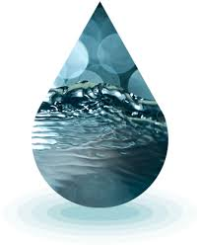
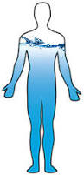
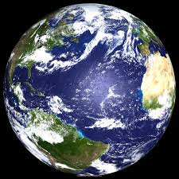

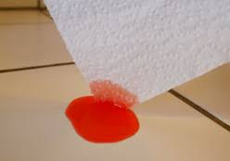
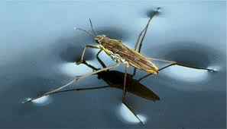
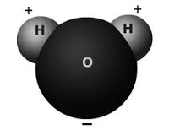

What Makes it So Special?

Have You Heard?

70% of Earth is water. | All living things need water to survive.
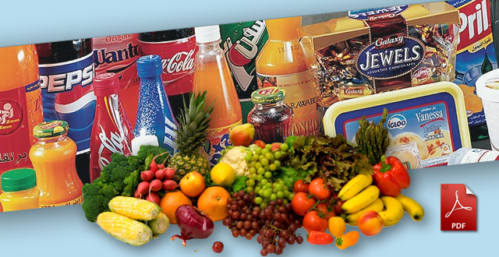  There is water in almost everything we eat and drink. | 70% of the human body is water.
The average person in the United States uses 80 to 110 gallons of water per day.  Whhaaat?  Wait a minute. | 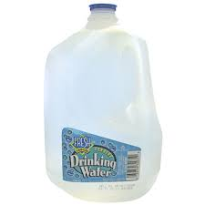  That’s 80 to 110 of these per person, per day!

So what do we know about water?
- 70% of our planet and our bodies are made of water.
- All of our food contains at least some water.
- Water is needed for survival.
- Humans use water for many things every day.

But why?
Why is water found in so many things?
Why do we need water for so many things?
What makes water so special?
H2O – Special Building Blocks
In this article you will read about the many special things that water can do, but first you need to understand what water is. Maybe you’ve heard the term H2O – a sort of nickname for water. Well, H2O stands for the chemical make up of water. Like all substances, water is made up of molecules (groups of atoms). Every water molecule is made up of 2 hydrogen atoms, and 1 oxygen atom. It looks like Mickey Mouse.

Just like a battery or a magnet, water molecules have one side that is positively charged, and one side that is negatively charged. The hydrogen atoms have a positive charge, and the oxygen atoms have a negative charge.

It’s always hard for me to remember. Is it 2 hydrogen or 2 oxygen? Which one is negative and which one is positive? Having a picture and a story can help. I picture the O for oxygen as Mickey’s mouth saying “Oh (O) no!” in a negative (-) way. There is only one mouth, so there is only one negative oxygen atom. Then, I think about Mickey’s two ears. What does he use his ears for? Yes, hearing – H for hydrogen. Mickey is very good at hearing with those large ears; that’s a positive trait. There are two ears, so there are two positive hydrogen atoms.

Label this Mickey:
- “O” for the oxygen atom on the face,
- “H”s for the hydrogen atoms on the ears
- - sign for oxygen atom
- + sign for hydrogen atoms

Cohesion– Water Molecules have a Special Bond
You read in the last section that a water molecule’s oxygen atom has a negative charge, and its hydrogen atoms have a positive charge. The two parts of a water molecule have opposite charges – positive and negative. That is similar to how a magnet has opposite poles, or ends –
north and south.
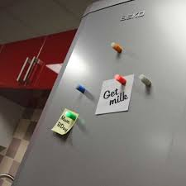  I’m sure you’ve seen how magnets are attracted to each other and stick to other things, but have you ever wondered why? | 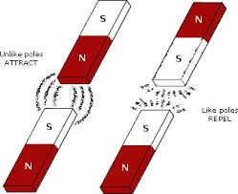  In the picture below, you can see that opposite poles attract (come together) and like poles repel (push away from each other).

So, magnets stick to each other when their opposite poles face each other.

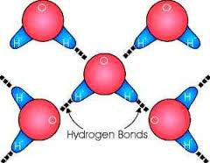
Water molecules act in a similar way. The positive hydrogen atoms and the negative oxygen atoms are attracted to each other.

This attraction forms a tight bond and makes water very cohesive. The molecules stick together.
Surface Tension – Special Effect of that Special Bond
Cohesion (stickiness) between water molecules causes water to have surface tension. Molecules on the surface (top) of water are more attracted to each other than they are to the molecules of the air above. Surface molecules cling even more tightly together, creating a “skin-like” elastic layer on the surface of water. This surface tension causes water molecules to clump together in drops.

You can notice many things in the world that show water’s cohesiveness and surface tension.
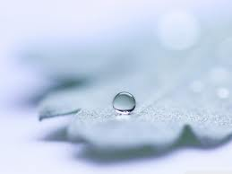
Water drops keep their rounded shape.

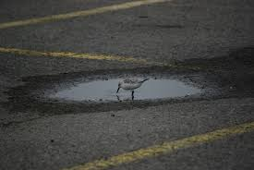
Water pools together and doesn’t spread out as
quickly as other liquids.

Some insects seem to be able to “walk on water” because the tension on the surface is difficult to break through.

Adhesion –Reaching out to Different Molecules

I think you’ve gotten the picture. Water molecules bond together. They are very attracted to each other. They are a cohesive group. You might be thinking that such a cohesive group of water molecules wouldn’t want to hang out with, or stick to, anything else. Well, luckily, that’s not true. Actually, water molecules are quite adhesive – they can “stick to” many other substances. In fact, because water has a positive and negative charge, it can “stick to” any other substance that has a negative or positive charge.
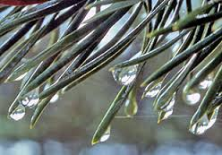

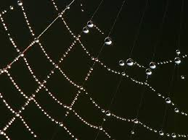

Adhesion allows water to stick to other substances like paper, so that it can be absorbed. Think about how hard it would be to clean up a mess with paper towels if water wasn’t adhesive.
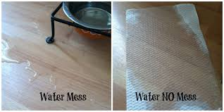

Capillary Action - Cohesion and Adhesion at Work Together
Adhesion and cohesion work together to make water do some pretty cool things. But, before we get into that, let’s make sure we remember the meaning of those two words cohesion and adhesion.

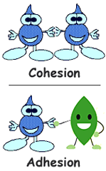
Take a minute to look at what is the same in both of those words. Yes – hesion. The root –hesion means, “to stick”. You know both words have to do with molecules sticking together.

Cohesion has the prefix co- like in cooperate. You can think about people on the same team cooperating, and that will help you to remember that cohesion means molecules of the same substance are attracted to each other.

Notice that adhesion begins with the prefix ad-. That can help you to remember that with adhesion you are adding on – the molecules of the first substance are sticking to the molecules of an additional substance.

Adhesion and cohesion work together to make capillary action happen. Capillary action is when water moves through porous spaces (small holes and tubes). Water can even move up, against gravity!

How does it do that?
1. Water molecules are attracted to, and stick to, the edges of hollow passages because of adhesive force.  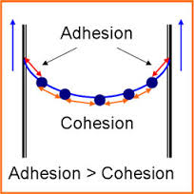 | 2. Water molecules start to travel up, or along, the passages. Then, because of cohesion, those molecules pull other water molecules along and up.  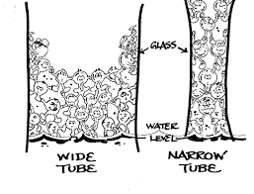

Capillary action allows water to travel…

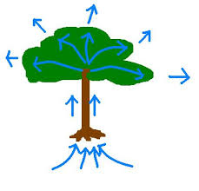
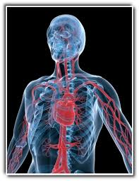
up a paper towel, up plant roots, and through our bodies.

Together adhesion and cohesion allow water to flow, and to transport important nutrients, waste, and minerals.

Conclusion
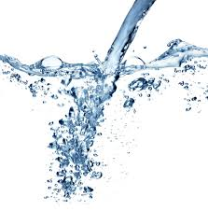
Because water is cohesive, it sticks to itself and flows. Because water is adhesive, other things stick to it and can go along for the ride. Water carries important nutrients from soil to plants. Plants also use water to make their food. Water carries nutrients and oxygen all over your body. Water caries waste out of your body.

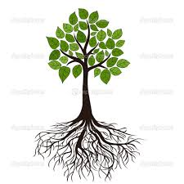
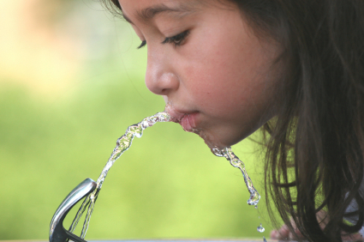

Now you are beginning to see just what is so SPECIAL about WATER!

Vocabulary Builder

Directions: Complete this worksheet as you read the text.

cohesive: adjective - describes a group that is united or sticks together
Water is cohesive because it’s molecules stick together.
Name a time when it is good for a group of people to be cohesive. ____________________________
_______________________________________________________________________________________________________

The word cohesion begins with the prefix co-, which means together or jointly.
List at least three words that start with the prefix co-. Write the meaning of each.
_______________________________________________________________________________________________________
_______________________________________________________________________________________________________
_______________________________________________________________________________________________________
_______________________________________________________________________________________________________

bond: noun – the attractive force that holds molecules together; a strong connection between people
Name a person who you have a tight bond with and explain why.
_____________________________ and I have a tight bond because… __________________________________
_______________________________________________________________________________________________________
_______________________________________________________________________________________________________

surface tension: noun - elastic like force on the outer layer of water
Surface is a noun that means the top or outside face of something. What are some things you might put on the surface of a table? ________________________________________________________
_______________________________________________________________________________________________________
_______________________________________________________________________________________________________

Tension is a noun that means the state of being stretched. When you stretch a rubber band, the tension keeps it from being pulled apart. Can you think of other examples of tension? ___________________________________________________________________________________________

